Run as Sub_request = False

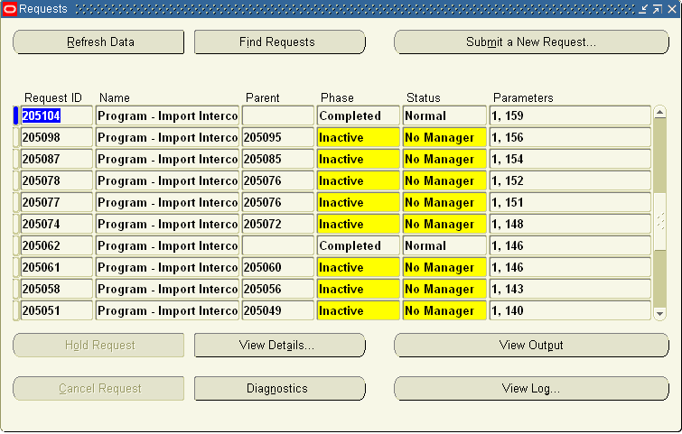
Run as Sub_request = True

